Project 2: Handshake Mastery — Valid/Ready Register Slice + Backpressure Demonstrations
1. Pre-flight Overview
1.1 Abstract
Build a production-quality valid/ready register slice (single-entry elastic pipeline stage) that absorbs backpressure without dropping or reordering data. Prove correctness with a self-checking SystemVerilog testbench that injects randomized stall patterns and prints a reproducible PASS/FAIL summary. Save contest-grade logs and wave evidence from XSIM (Vivado Simulator).
1.2 Project Aim
Implement a reusable, parameterized register slice that obeys the ready/valid contract under all stall patterns, then demonstrate behavior with clear timing evidence: stable valid/data while stalled, correct backpressure propagation to the producer, and in-order delivery with zero drops.
1.3 Design Architecture / Block Diagram
Textual diagram (monospaced):
READY/VALID REGISTER SLICE
Producer side Register Slice Consumer side
(in_valid, in_data) +-------------------+ (out_valid, out_data)
(in_ready) <----------------| in_ready logic|--------------> (out_ready)
| storage (reg) |
| out_valid logic|
+-------------------+
Key property:
- If out_ready=0 while out_valid=1, the slice must HOLD data and keep out_valid=1.
- in_ready must deassert to apply backpressure when storage is full.
How a token moves from producer → slice → consumer, and what happens when the consumer stalls for many cycles?

A token originates from the producer, which asserts in_valid along with the corresponding in_data. The register slice checks whether it can accept the token by asserting in_ready. A transfer from the producer to the slice occurs only when both in_valid and in_ready are high in the same clock cycle.
Once accepted, the slice stores the token internally by setting stored_valid = 1 and saving the data in stored_data. The slice then presents the stored token to the consumer by asserting out_valid and placing the token on out_data.
The consumer indicates it is ready to receive data by asserting out_ready. When both out_valid and out_ready are high, the token is transferred to the consumer and removed from the slice. This allows the slice to accept the next token.
If the consumer stalls (out_ready = 0) while the slice is holding a valid token (out_valid = 1), the slice must hold the data constant and keep out_valid asserted. During this time the slice may deassert in_ready to prevent new tokens from overwriting the stored data.
Once the consumer becomes ready again (out_ready = 1), the stored token is delivered and the slice becomes available to accept new input tokens. This mechanism ensures no data is dropped and the ordering of tokens is preserved even during long stall periods.

1.4 End-to-End Procedure (what success looks like)
- Write the ready/valid contract in docs/handshake.md (transfer condition, stability rules, and state transitions).
- Implement a single-entry elastic register slice RTL (parameterized width) with reset clearing the stored-valid bit.
- Write a self-checking SV testbench that sends an incrementing token stream and randomizes out_ready to create backpressure.
- Add protocol assertions and a monitor so bugs fail fast with actionable logs.
- Run multi-seed regressions in XSIM, save a transcript log for each run, and capture wave screenshots for key stall patterns.
- Optionally implement a skid-buffer variant and compare throughput/latency evidence.

Why is a signature-like PASS/FAIL summary better than “I looked at the waveform and it seemed OK”?

A PASS/FAIL summary provides an automated and deterministic verification result rather than relying on manual waveform inspection. Waveforms can show whether signals look correct, but they require a human to visually inspect many cycles and may miss subtle errors.
A signature-like summary generated by a self-checking testbench automatically verifies correctness across thousands of cycles and tokens. If a mismatch occurs, the testbench prints the exact cycle, token value, and expected value, making debugging faster.
This approach also allows regression testing, where the same test can be run repeatedly with different seeds or configurations. Since the seed and token count are recorded in the summary, any failure can be reproduced exactly.
Therefore, automated PASS/FAIL summaries provide objective verification, faster debugging, and reproducibility, which is the standard approach used in professional hardware verification environments.
2. Pre-flight Knowledge

- Ready/valid handshake: fire event = valid && ready, and what it means for throughput vs latency.
- Stability rule: when valid=1 and ready=0, the sender must hold data stable until transfer completes.
- Elastic buffering: how a 1-entry buffer can accept new data in the same cycle the old data is accepted (replacement behavior).
- Backpressure: how and when in_ready must deassert to prevent overwrite and data loss.3
- Waveform-first debug: finding the failing token index in the log, then jumping to the exact waveform cycle.
- Reproducible randomness: using +seed and printing it in every summary so failures repeat exactly.
3. Tool Installation + Sanity Checks (with screenshots)
This project uses 100% free resources. Use Vivado ML Standard (free) which includes XSIM (Vivado Simulator) and the Vivado waveform viewer.
3.1 Install Vivado ML Standard (Windows 10/11)
- Open your web browser and search for “Vivado ML Standard download”.
- Create or sign in to your AMD/Xilinx account when prompted.
- Download the Vivado ML Standard installer for your OS (choose the full installer if your internet is unstable).
- Run the installer as Administrator.
- In the component selection screen, ensure these are selected: Vivado Design Suite, XSIM (simulation), and device support you may need later (you can keep defaults).
- Choose an install location with enough free space (Vivado is large).
- Complete installation and reboot if prompted.
3.2 Confirm XSIM commands are available
- Open the Start menu.
- Search for “Vivado”.
- Open “Vivado Tcl Shell” (recommended) OR open a normal Command Prompt after launching Vivado once.
- Type the version commands below and confirm each prints a version string.
xvlog -version
xelab -version
xsim -version
What does it prove when a tool prints a version string? (Hint: installation + PATH/environment are correct.)
When a tool prints its version string, it proves that the executable is installed correctly and accessible through the system environment. It confirms that the operating system can locate and run the tool using the current PATH configuration.
This also verifies that the installation completed successfully and that all required dependencies for that tool are present. If the version command works, it means the simulation tools are ready to compile, elaborate, and run designs.

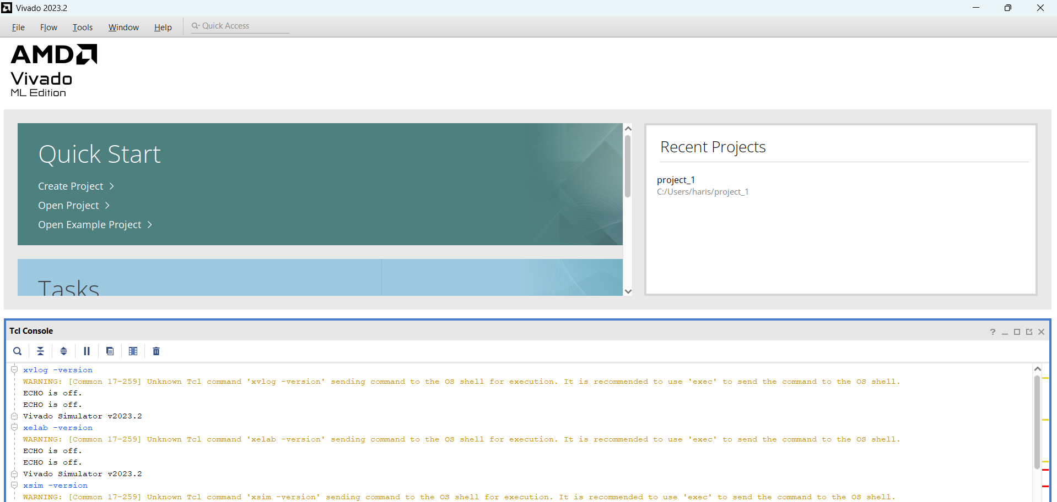
A terminal showing version outputs for xvlog/xelab/xsim (file: screenshots/ss1_xsim_versions.png).

3.3 Create the project workspace (No Git)
Follow the same evidence-first folder discipline as Project 1. If you already created your evidence templates (RECORD_LOG, screenshots folder rules) in Project 1, reuse them here instead of rewriting. Refer to the Project 1 manual’s workspace + evidence sections for the philosophy and screenshot naming conventions.
Create this project directory structure:
project_root/handshake_mastery/
rtl/ # synthesizable RTL (reg_slice, optional skid)
tb/ # SystemVerilog self-checking testbench
sim/ # build/run scripts for XSIM
results/ # per-run folders: logs + wdb + metadata
screenshots/ # curated evidence screenshots
docs/ # handshake rules, truth table, notes
- Choose a location on your PC where you keep VLSIVault projects.
- Create a folder named handshake_mastery.
- Inside it, create rtl, tb, sim, results, screenshots, and docs.
# From a terminal in your chosen workspace directory:
mkdir handshake_mastery
cd handshake_mastery
mkdir rtl tb sim results screenshots docs
Folder Purpose Explanation
rtl/
Contains synthesizable hardware modules written in SystemVerilog. These files represent the actual hardware design that could later be synthesized onto an FPGA or ASIC.
tb/
Contains SystemVerilog testbench files used for verification. These modules generate stimulus, check outputs, and validate that the RTL behaves correctly.
sim/
Contains scripts that automate compilation, elaboration, and simulation runs. These scripts make simulations reproducible and easy to execute.
results/
Stores the output of each simulation run, including logs, waveform databases, and metadata. Each run typically has its own folder to preserve reproducibility.
screenshots/
Stores curated evidence images required for documentation and reporting, such as waveforms and tool outputs.
docs/
Contains design documentation such as handshake rules, state models, and test plans. These files describe the design decisions and verification strategy.

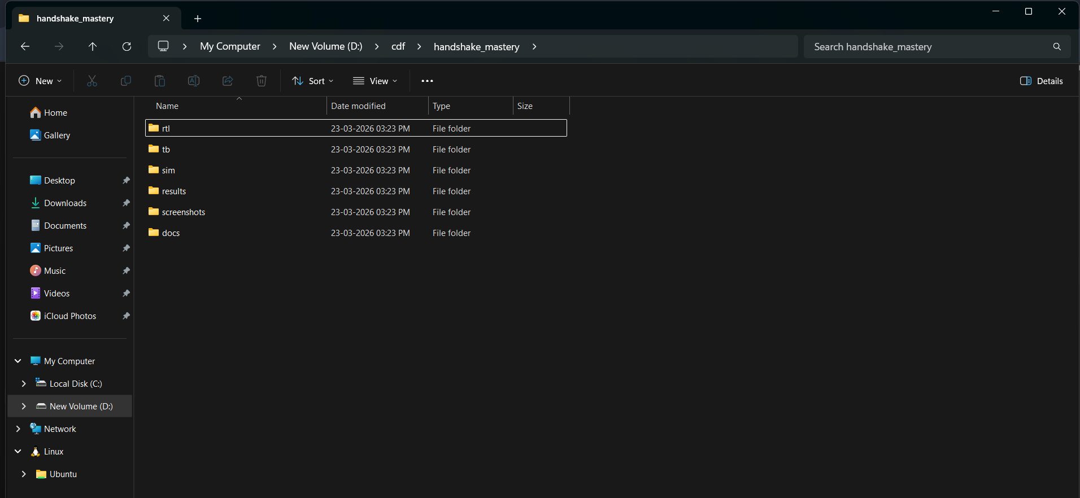
folder tree after creation

3.4 XSIM waveform smoke test (before the real RTL)
You will first prove that your simulator can compile, run, and generate a waveform database you can inspect. This prevents wasting hours later debugging ‘why no waves’ issues.
Create tb/smoke.sv:
// tb/smoke.sv
`timescale 1ns/1ps
module smoke;
logic clk = 0;
logic rst = 1;
logic a;
always #5 clk = ~clk;
initial begin
a = 0;
repeat (3) @(posedge clk);
rst = 0;
repeat (5) begin
@(posedge clk);
a <= ~a;
end
$finish;
end
endmodule
Compile + elaborate + run:
# From project_root/handshake_mastery
xvlog -sv tb/smoke.sv
xelab smoke -debug typical -s sim_smoke
xsim sim_smoke -R
- After the run finishes, re-run with GUI so you can view waves.
- In the GUI, add signals clk, rst, and a to the wave window.
- Zoom-to-fit and verify a toggles after reset deasserts.
xsim sim_smoke -gui
What is the fastest way to debug RTL: log-first or wave-first? When would you use each?
The fastest debugging method depends on the type of problem.
Log-first debugging is usually the fastest when identifying functional failures such as incorrect tokens or mismatches. Logs immediately reveal which token failed and at what simulation time.
Waveform-first debugging is useful when diagnosing timing or handshake issues. Once a failing token is identified from the log, the waveform viewer can be used to inspect the exact signal transitions that caused the failure.
In practice, the most efficient workflow is log-first to locate the failure and wave-second to analyze the root cause.

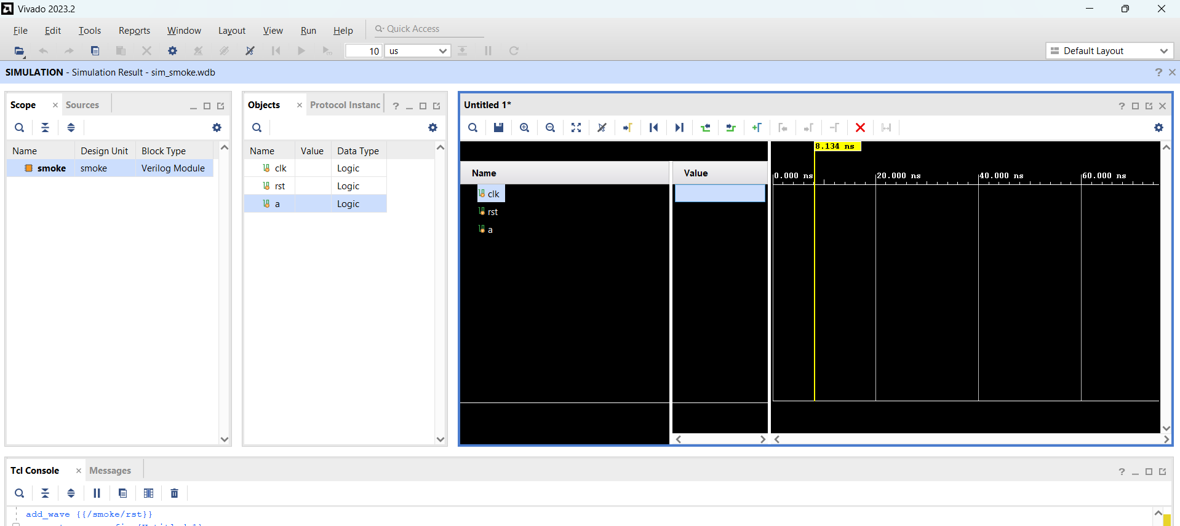

XSIM GUI showing clk/rst/a toggling

4. Module 0 - Handshake Rules and Truth Table
Outcome: a clear, testable handshake contract that your RTL and testbench will follow exactly.
4.1 Write the handshake contract (docs/handshake.md)
- Open your editor.
- Create docs/handshake.md.
- Write the rules below (copy and then edit with your own words to prove you understand).
# Ready/Valid Handshake Contract (Register Slice)
- Transfer condition (fire event):
fire = valid && ready
- Stability rule (sender responsibility):
If valid=1 and ready=0, sender must keep:
- valid asserted
- data stable
until fire occurs.
- No drop / in-order rule:
Every token accepted at the input must appear exactly once at the output, in the same order.

Why is 'fire = valid && ready' the only moment a transfer is allowed to be counted?

The condition fire = valid && ready ensures that both the sender and receiver agree on the transfer of data in the same clock cycle. The sender indicates that the data is valid, while the receiver indicates that it is ready to accept the data.
If only valid is high but ready is low, the receiver is not prepared to accept the data, so the transfer cannot occur. Similarly, if ready is high but valid is low, there is no valid data to transfer.
By defining the transfer event strictly as valid && ready, the system prevents data loss, duplication, or misinterpretation of partial transfers. This rule guarantees that each token is transferred exactly once and maintains proper synchronization between the producer and consumer.

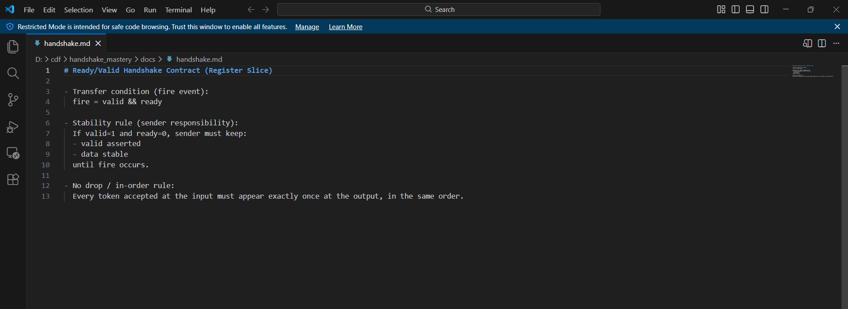
docs/handshake.md showing my final contract text

4.2 Create the empty/full state model (truth table + state diagram)
Your register slice will be modeled as a single storage entry. It is either EMPTY (no stored token) or FULL (holding a token that has not been accepted by the consumer).
- In docs/handshake.md (or a new docs/state_model.md), write a small truth table for how FULL changes each cycle.
- Use these signals: in_valid, in_ready, out_valid, out_ready, and an internal stored_valid (FULL).
- Write the two key derived signals: fire_in = in_valid && in_ready, fire_out = out_valid && out_ready.

FULL/EMPTY Truth Table + State Diagram
Your register slice is a single-entry elastic buffer, so internally it really has only two states:
- EMPTY → no token stored
- FULL → one token stored and waiting to be consumed
The internal state bit is:
- stored_valid = 0 → EMPTY
- stored_valid = 1 → FULL
Also define the two handshake events:
- fire_in = in_valid && in_ready
- fire_out = out_valid && out_ready
Since out_valid = stored_valid, the output can only fire when the buffer is FULL.
The register slice behaves like a one-entry storage element with two possible states: EMPTY and FULL. When the slice is EMPTY, it can accept a token from the producer if in_valid is asserted. When that happens, fire_in occurs and the state becomes FULL.
When the slice is FULL, it presents the stored token to the consumer by asserting out_valid. If the consumer is not ready (out_ready = 0), the slice must remain FULL, keep out_valid = 1, and hold out_data stable. At the same time, in_ready must deassert so the producer does not overwrite the stored token.
If the slice is FULL and the consumer is ready (out_ready = 1), the current token can leave the slice. In the same cycle, if a new input token is also valid, the slice performs a replacement: the old token is consumed and the new token is stored immediately, so the state remains FULL. If no new token is presented in that cycle, the slice becomes EMPTY after the output transfer.
This behavior provides backpressure safety, preserves ordering, and allows one token per cycle throughput when both sides are active.
State / transition truth table
Definitions:
stored_valid = 0 -> EMPTY
stored_valid = 1 -> FULL
out_valid = stored_valid
in_ready = (~stored_valid) | out_ready
fire_in = in_valid && in_ready
fire_out = out_valid && out_read
Current State | in_valid | out_ready | in_ready | fire_in | fire_out | Next State | Meaning
EMPTY | 0 | 0 | 1 | 0 | 0 | EMPTY | Nothing stored, no input arrives
EMPTY | 0 | 1 | 1 | 0 | 0 | EMPTY | Still empty
EMPTY | 1 | 0 | 1 | 1 | 0 | FULL | New token enters buffer
EMPTY | 1 | 1 | 1 | 1 | 0 | FULL | New token enters buffer
FULL | 0 | 0 | 0 | 0 | 0 | FULL | Stall: hold token stable
FULL | 1 | 0 | 0 | 0 | 0 | FULL | Stall: block producer, hold token
FULL | 0 | 1 | 1 | 0 | 1 | EMPTY | Consumer takes token, no replacement
FULL | 1 | 1 | 1 | 1 | 1 | FULL | Simultaneous consume + refill

When the buffer is FULL and out_ready=0, what must happen to in_ready and why?
When the buffer is FULL and out_ready = 0, in_ready must be deasserted (in_ready = 0). This prevents the producer from sending a new token that would overwrite the token already stored in the register slice. In this condition, the slice must hold the current token stable and apply backpressure upstream until the consumer accepts the stored data.
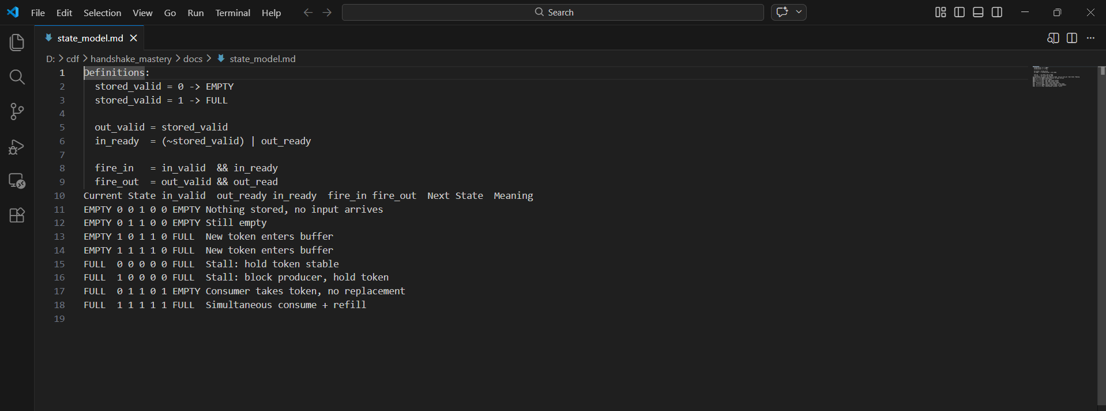
Truth table and state diagram

4.3 Define pass criteria for this project (docs/test_plan.md)
- Create docs/test_plan.md.
- Write pass criteria that your testbench will enforce.
- Include: number of tokens, seed control, and what evidence files must be saved per run.
# Test Plan (Register Slice)
- Directed tests:
- no stalls (out_ready always 1)
- long stall burst (out_ready held 0 for many cycles)
- single-cycle random stalls
- Random tests:
- N tokens (default 2000)
- repeatable +seed
- multiple seeds (at least 3)
- PASS criteria:
- received_count == sent_count == N
- no mismatches
- assertions never fire
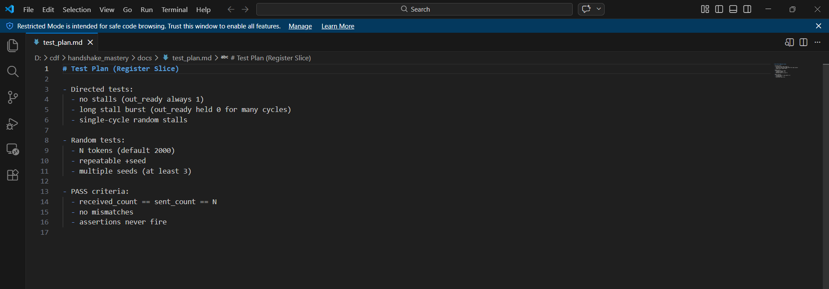
docs/test_plan.md with my PASS criteria.

5. Module 1 - RTL: Single-Entry Register Slice
Outcome: synthesizable RTL for a one-entry elastic buffer that obeys the handshake contract under all backpressure scenarios.
5.1 Implement rtl/reg_slice.sv (single-entry elastic buffer)
Create rtl/reg_slice.sv:
// rtl/reg_slice.sv
`timescale 1ns/1ps
module reg_slice #(
parameter int W = 32
)(
input logic clk,
input logic rst_n,
// Producer side
input logic in_valid,
input logic [W-1:0] in_data,
output logic in_ready,
// Consumer side
output logic out_valid,
output logic [W-1:0] out_data,
input logic out_ready
);
logic stored_valid;
logic [W-1:0] stored_data;
// Elastic rule:
// Can accept new input if buffer is empty OR consumer is ready to take current item.
always_comb begin
in_ready = (~stored_valid) | out_ready;
out_valid = stored_valid;
out_data = stored_data;
end
// Storage update:
// If in_ready=1, we may load new data (or clear if in_valid=0).
always_ff @(posedge clk) begin
if (!rst_n) begin
stored_valid <= 1'b0;
stored_data <= '0;
end else if (in_ready) begin
stored_valid <= in_valid;
if (in_valid) stored_data <= in_data;
end
end
endmodule
Why in_ready is computed as (~stored_valid) | out_ready. What scenario does this enable in one cycle?
This logic allows the slice to accept new input data in two situations.
First, when the buffer is empty (stored_valid = 0), the slice can always accept a new token, so in_ready is asserted.
Second, when the buffer is full but the consumer is ready (out_ready = 1), the stored token will be transferred out during the same clock cycle. Since the buffer becomes free in that cycle, the slice can simultaneously accept a new input token.
This behavior enables elastic pipeline operation, where a token can exit and a new token can enter in the same clock cycle, maintaining high throughput without requiring multiple storage entries.
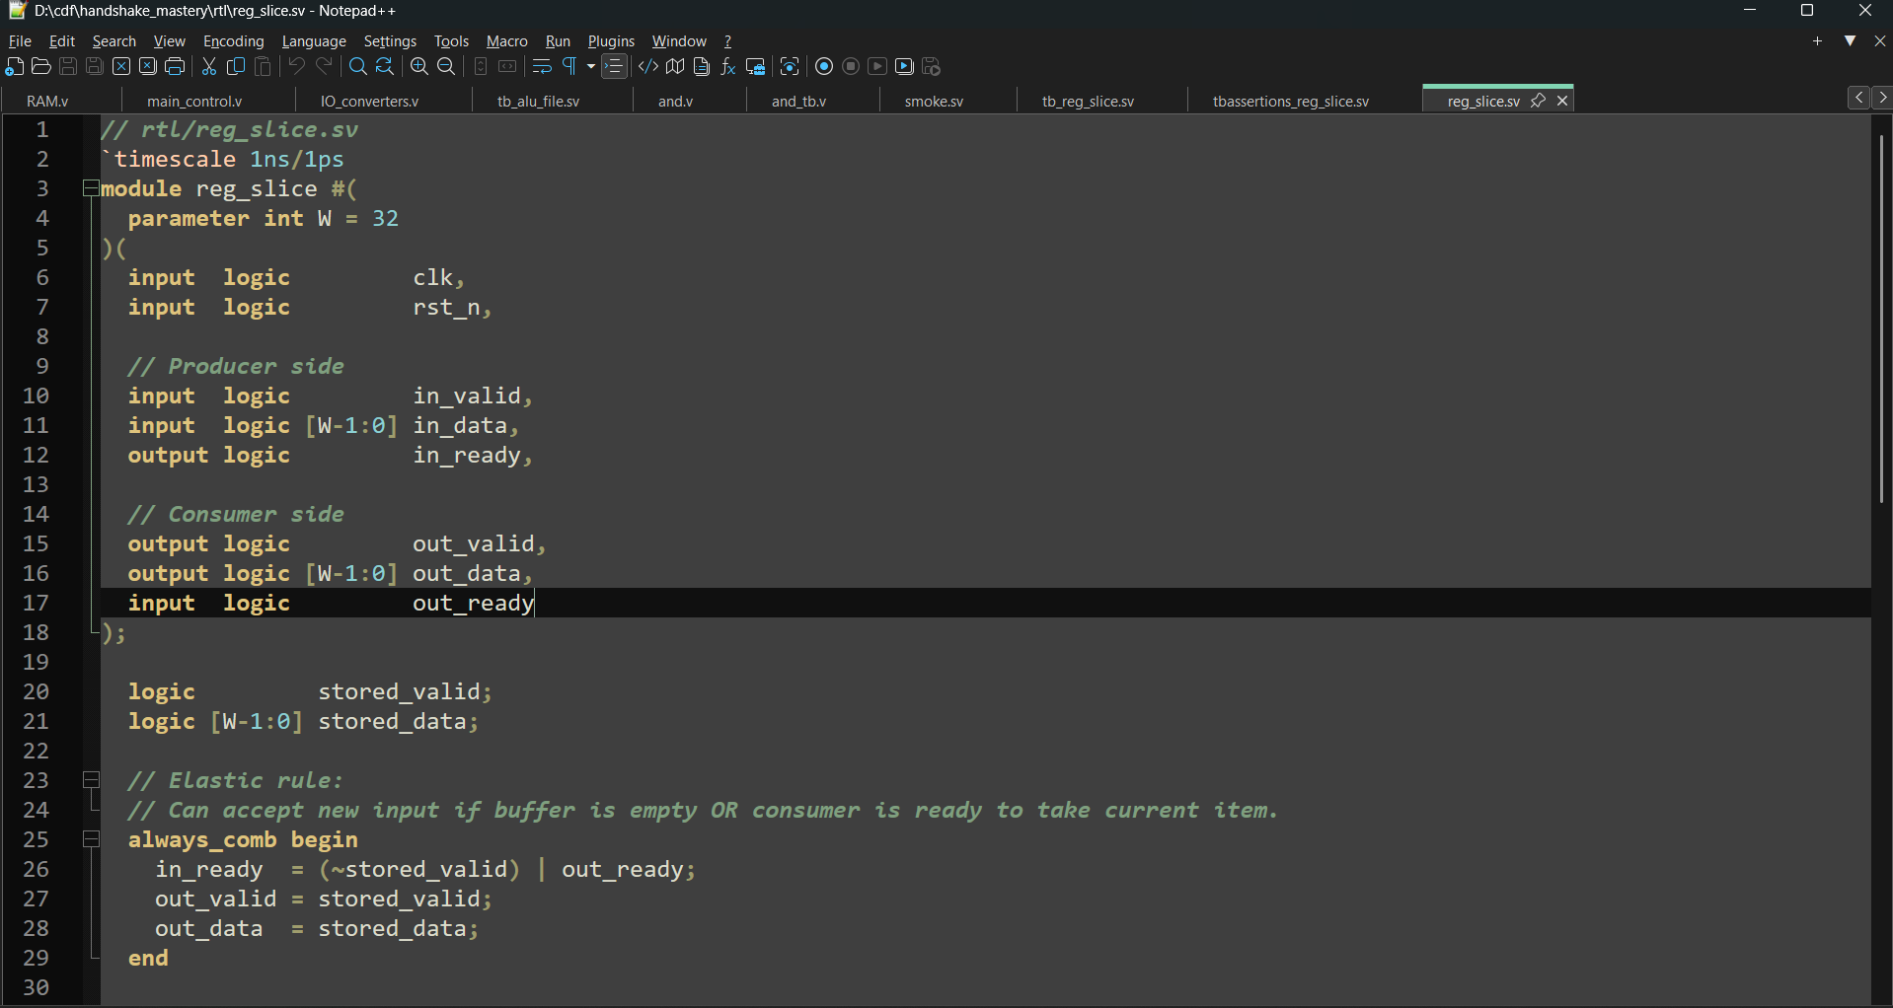
rtl/reg_slice.sv opened in the editor
5.2 Build a minimal wrapper test (no random yet)
Before writing a large randomized test, do a small bring-up run where the consumer is always ready. This confirms basic wiring and counters.
- Create a minimal testbench first (you will expand it in Module 2).
- In this mini test, drive in_valid and in_data for a small number of tokens.
- Set out_ready = 1 always.
- Confirm out_valid pulses and out_data matches.

5.3 Create sim/build_and_run_xsim.(bat or .sh)
You want a single entrypoint command that compiles, elaborates, and runs the simulation. This also makes evidence capture reproducible.
Create sim/run_xsim.bat (Windows) OR sim/run_xsim.sh (Linux). Example Windows .bat:
@echo off
setlocal enabledelayedexpansion
set SEED=%1
if "%SEED%"=="" set SEED=7
set N=%2
if "%N%"=="" set N=2000
set TAG=%3
if "%TAG%"=="" set TAG=regslice_smoke
for /f %%i in ('powershell -NoProfile -Command "Get-Date -Format yyyyMMdd"') do set DATE=%%i
set RUN_DIR=results\run_%DATE%_seed%SEED%_%TAG%
mkdir %RUN_DIR% 2>nul
echo xvlog -sv rtl/reg_slice.sv tb/tb_reg_slice.sv > %RUN_DIR%\command.txt
echo xelab tb_reg_slice -debug typical -s sim_slice >> %RUN_DIR%\command.txt
echo xsim sim_slice -R +seed=%SEED% +n=%N% -log %RUN_DIR%\transcript.log -wdb %RUN_DIR%\waves.wdb >> %RUN_DIR%\command.txt
xvlog -sv rtl/reg_slice.sv tb/tb_reg_slice.sv
if errorlevel 1 exit /b 1
xelab tb_reg_slice -debug typical -s sim_slice
if errorlevel 1 exit /b 1
xsim sim_slice -R +seed=%SEED% +n=%N% -log %RUN_DIR%\transcript.log -wdb %RUN_DIR%\waves.wdb
echo seed=%SEED%> %RUN_DIR%\run_info.txt
echo n=%N%>> %RUN_DIR%\run_info.txt
echo tag=%TAG%>> %RUN_DIR%\run_info.txt
echo Run folder: %RUN_DIR%
What is the difference between compile (xvlog), elaborate (xelab), and run (xsim)?
Compile (xvlog)
The compile step reads the SystemVerilog source files and checks them for syntax and semantic errors. It converts the source code into an intermediate representation used by the simulator.
Elaborate (xelab)
During elaboration, the simulator resolves module hierarchies, parameter values, and signal connections. It builds the complete simulation model of the design and prepares an executable simulation snapshot.
Run (xsim)
The run step executes the simulation over time. The simulator applies stimulus, updates signals according to the design logic, and produces logs and waveform data.
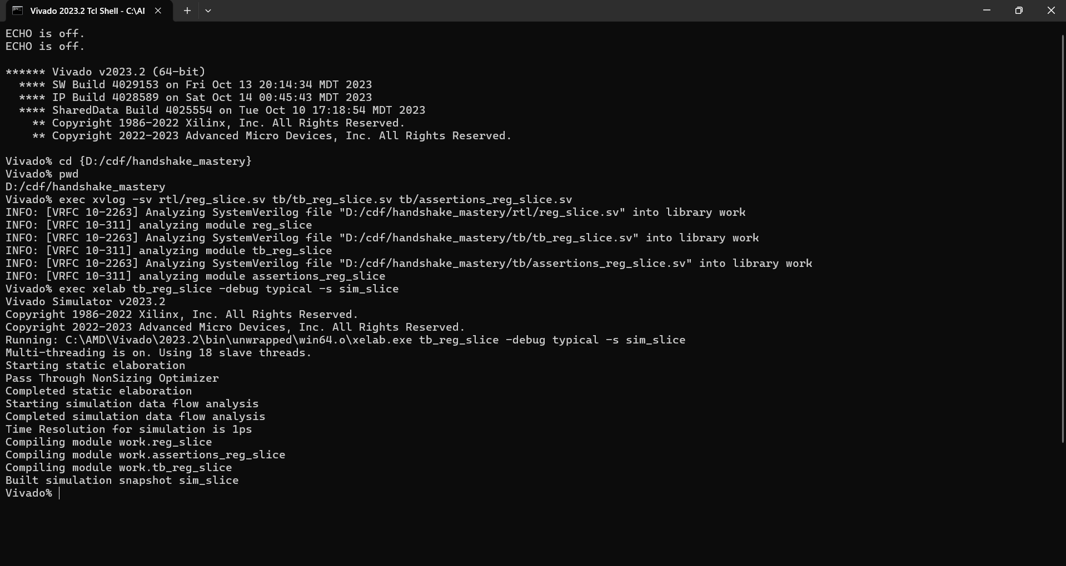
A terminal showing a successful xvlog+xelab+run
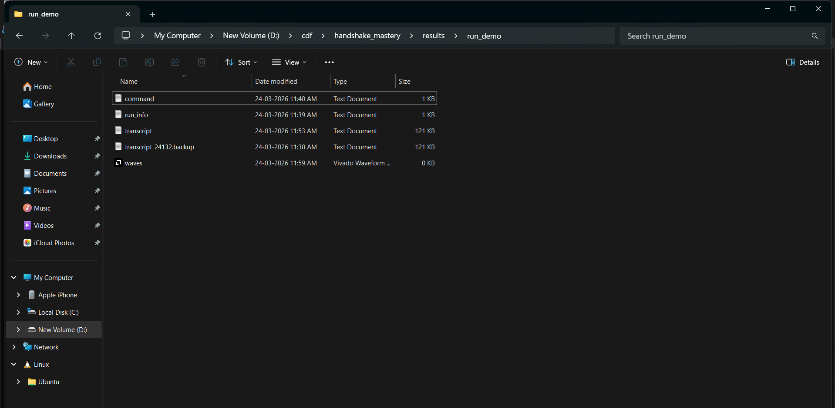
run folder containing command.txt, transcript.log, waves.wdb, run_info.txt

6. Module 2 - Verification: Randomized Backpressure
Outcome: a self-checking testbench that proves no drops, in-order delivery, and reproducibility under randomized stalls.
6.1 Create tb/tb_reg_slice.sv (self-checking TB)
Create tb/tb_reg_slice.sv. This testbench generates an incrementing token stream, randomizes out_ready, and checks every output token against the expected sequence.
// tb/tb_reg_slice.sv
`timescale 1ns/1ps
module tb_reg_slice;
localparam int W = 32;
logic clk = 0;
logic rst_n = 0;
logic in_valid;
logic [W-1:0] in_data;
logic in_ready;
logic out_valid;
logic [W-1:0] out_data;
logic out_ready;
// DUT
reg_slice #(.W(W)) dut (
.clk(clk), .rst_n(rst_n),
.in_valid(in_valid), .in_data(in_data), .in_ready(in_ready),
.out_valid(out_valid), .out_data(out_data), .out_ready(out_ready)
);
// Clock
always #5 clk = ~clk;
// Plusargs
int unsigned seed;
int n_tokens;
// Scoreboard counters
int unsigned sent;
int unsigned recv;
int unsigned exp_token;
// Random helper (deterministic per seed)
function automatic int unsigned urand();
seed = seed * 32'h9E3779B9 + 32'h7F4A7C15;
return (seed ^ (seed >> 16));
endfunction
task automatic fail(input string msg);
$display("[FAIL] %s", msg);
$display("[FAIL] seed=%0d sent=%0d recv=%0d exp=%0h got=%0h time=%0t",
seed, sent, recv, exp_token, out_data, $time);
$finish;
endtask
initial begin
// Defaults
in_valid = 0;
in_data = '0;
out_ready= 0;
// Read plusargs
if (!$value$plusargs("seed=%d", seed)) seed = 7;
if (!$value$plusargs("n=%d", n_tokens)) n_tokens = 2000;
sent = 0;
recv = 0;
exp_token = 0;
// Reset
repeat (3) @(posedge clk);
rst_n <= 1;
repeat (1) @(posedge clk);
// Main loop: run until all tokens received
while (recv < n_tokens) begin
// Randomize consumer ready (stall patterns)
// 70% ready by default, with occasional burst stalls
int unsigned r = urand() % 100;
out_ready <= (r < 70);
// Drive producer
in_valid <= (sent < n_tokens); // keep trying until N accepted
in_data <= sent[W-1:0]; // token is the sequence number
@(posedge clk);
// Count input transfers
if (in_valid && in_ready) begin
sent <= sent + 1;
end
// Check output transfers
if (out_valid && out_ready) begin
if (out_data !== exp_token[W-1:0]) begin
fail($sformatf("Token mismatch at recv=%0d", recv));
end
exp_token <= exp_token + 1;
recv <= recv + 1;
end
end
$display("[SUMMARY] seed=%0d n=%0d sent=%0d recv=%0d FAIL=0", seed, n_tokens, sent, recv);
$finish;
end
endmodule
How does this testbench guarantee “no drops” and “in-order” even under stalls? Point to the exact lines that enforce it.
The testbench guarantees correct behavior using a sequence counter and scoreboard comparison.
The producer sends tokens using in_data <= sent, which means each token carries a unique sequence number corresponding to the order in which it was generated. The variable sent increments only when in_valid && in_ready is true, ensuring that tokens are counted only when they are actually accepted by the register slice.
At the output, the testbench checks every received token against an expected sequence number stored in exp_token. Whenever a transfer occurs (out_valid && out_ready), the testbench compares out_data to exp_token.
If the values do not match, the fail() task is triggered, immediately terminating the simulation and printing an error message. After a successful match, exp_token and recv are incremented.
Because each received token must match the expected sequence exactly, this mechanism guarantees both no token loss and strict in-order delivery, even under randomized stall conditions.

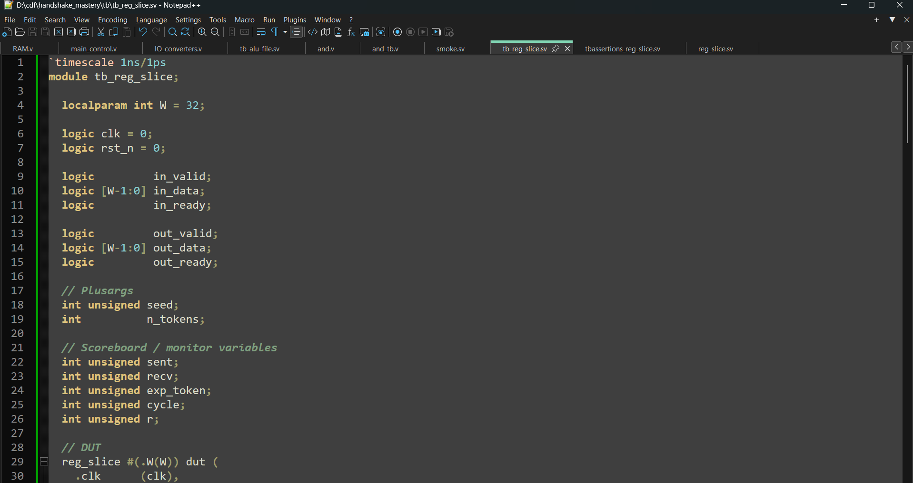
tb/tb_reg_slice.sv opened in the editor

6.2 Run a first randomized test and capture a PASS summary
Run using your run script (example):
# Windows:
sim\run_xsim.bat 7 2000 stall70
# Expected: transcript ends with [SUMMARY] ... FAIL=0
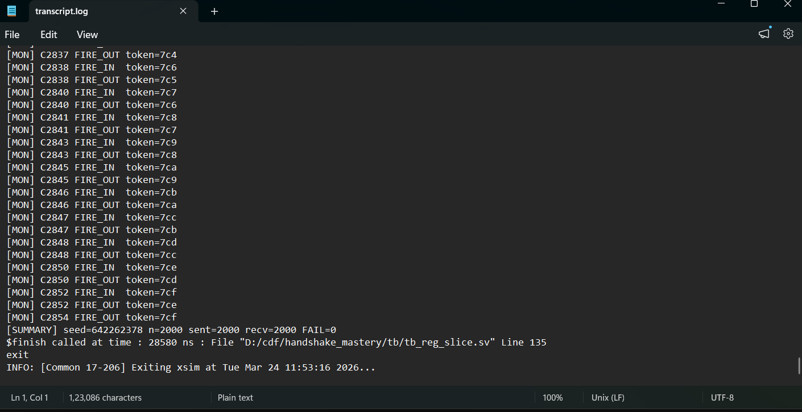
transcript.log showing the final [SUMMARY] line with FAIL=0
6.3 Capture two waveform scenarios (stall burst + single-cycle stalls)
- Open the WDB from your run folder.
- Add signals: in_valid, in_ready, in_data, out_valid, out_ready, out_data, and internal stored_valid (expand DUT).
- Find a region where out_ready stays 0 for several cycles while out_valid stays 1 and out_data stays stable.
- Find a region with quick toggling stalls (out_ready flickers).
In the stall-burst region, point to the exact cycles where data is held stable. What would change if the RTL were buggy?
During a stall burst, the consumer keeps out_ready = 0 for several consecutive cycles while the slice holds a valid token (out_valid = 1). In this situation, the register slice must hold both out_valid and out_data constant.
The waveform should show out_valid remaining high while out_data stays unchanged across multiple cycles. This confirms that the slice correctly preserves the token during the stall.
If the RTL were buggy, one of several incorrect behaviors might occur. The stored data could change while stalled, indicating that new input data overwrote the existing token. Alternatively, out_valid might drop unexpectedly, causing the token to be lost. Either behavior would violate the ready/valid handshake contract.

Take a screenshot of: Wave screenshot showing a long stall burst with stable out_data (file: screenshots/S16_wave_stall_burst.png).
Take a screenshot of: Wave screenshot showing single-cycle stall behavior (file: screenshots/S17_wave_single_stalls.png).

7. Module 3 - Assertions and Protocol Monitors
Outcome: assertions that catch handshake contract violations immediately, plus a monitor that logs every transfer event with cycle number.
7.1 Add protocol assertions (tb/assertions_reg_slice.sv)
Create tb/assertions_reg_slice.sv and include it in compilation. These assertions are “SVA-lite”: simple, high-value checks.
// tb/assertions_reg_slice.sv
`timescale 1ns/1ps
module assertions_reg_slice #(parameter int W = 32) (
input logic clk,
input logic rst_n,
input logic out_valid,
input logic [W-1:0] out_data,
input logic out_ready
);
// If out_valid is high and out_ready is low, out_data must remain stable next cycle
property hold_data_while_stalled;
@(posedge clk) disable iff (!rst_n)
(out_valid && !out_ready) |=> (out_valid && $stable(out_data));
endproperty
assert property (hold_data_while_stalled)
else $fatal(1, "[ASSERT] out_data changed while stalled");
// out_valid should not spontaneously drop while stalled
property hold_valid_while_stalled;
@(posedge clk) disable iff (!rst_n)
(out_valid && !out_ready) |=> out_valid;
endproperty
assert property (hold_valid_while_stalled)
else $fatal(1, "[ASSERT] out_valid dropped while stalled");
endmodule
Instantiate this assertion module inside tb_reg_slice and connect the DUT signals.
Why do assertions make debugging faster than only checking end results? Give one concrete example from this project.
Assertions detect protocol violations immediately when they occur rather than allowing errors to propagate through the system.
For example, if out_data changes while out_valid is asserted and out_ready is deasserted, the assertion will trigger at the exact cycle where the violation occurs. Without assertions, the testbench might only detect a token mismatch hundreds of cycles later.
By stopping the simulation at the precise moment of failure, assertions make it much easier to identify the root cause of the problem.

Take a screenshot of: Your assertions file + instantiation in TB (file: screenshots/S18_assertions_added.png).
7.2 Add a simple transfer monitor
Add a monitor in tb_reg_slice.sv that prints each fire event with cycle count. This makes it easy to correlate logs to waves.
// Add inside tb_reg_slice.sv:
int unsigned cycle;
always_ff @(posedge clk) begin
if (!rst_n) cycle <= 0;
else cycle <= cycle + 1;
end
always_ff @(posedge clk) begin
if (rst_n && in_valid && in_ready) begin
$display("[MON] C%0d FIRE_IN token=%0h", cycle, in_data);
end
if (rst_n && out_valid && out_ready) begin
$display("[MON] C%0d FIRE_OUT token=%0h", cycle, out_data);
end
end
If you see duplicated tokens in the monitor, what are the top two RTL mistakes that could cause it?
If duplicated tokens appear in the monitor output, two common RTL mistakes are likely.
The first possibility is that the stored data is not cleared or updated correctly after a successful output transfer. This could cause the same token to be presented to the consumer multiple times.
The second possibility is incorrect handshake logic where out_valid remains asserted even after the token has already been accepted by the consumer. This could cause the consumer to repeatedly read the same token.
Both issues indicate that the register slice is not correctly implementing the valid/ready handshake protocol.


transcript.log showing several [MON] lines (file: screenshots/S19_monitor_log.png).

7.3 Prove your checker works: inject a controlled bug and catch it
You will intentionally break the RTL to prove the TB/assertions detect real violations. This is a credibility booster.
- Edit rtl/reg_slice.sv to add a temporary bug mode using a compile-time define.
- When INJECT_BUG is enabled, overwrite stored_data even when in_ready=0 (this can cause drops under backpressure).
- Compile once with the bug enabled, confirm failure, then compile again with bug disabled to confirm PASS.
// Add inside always_ff in rtl/reg_slice.sv (temporary demo only):
`ifdef INJECT_BUG
// BUG: overwrite storage every cycle even when not ready to accept new input
stored_valid <= in_valid;
if (in_valid) stored_data <= in_data;
`else
// Correct behavior
if (in_ready) begin
stored_valid <= in_valid;
if (in_valid) stored_data <= in_data;
end
`endif
Build/run with the bug enabled (example):
xvlog -sv -d INJECT_BUG rtl/reg_slice.sv tb/tb_reg_slice.sv tb/assertions_reg_slice.sv
xelab tb_reg_slice -debug typical -s sim_slice
xsim sim_slice -R +seed=7 +n=2000 -log results\bug_run\transcript.log -wdb results\bug_run\waves.wdb
Take a screenshot of: Failing log snippet showing either [FAIL] mismatch or an [ASSERT] fatal (file: screenshots/S20_bug_failure.png).
Take a screenshot of: Wave screenshot at the failure region showing overwrite/drop behavior (file: screenshots/S21_bug_wave.png).
Now remove the define (or remove the injected bug code) and rerun the same seed.

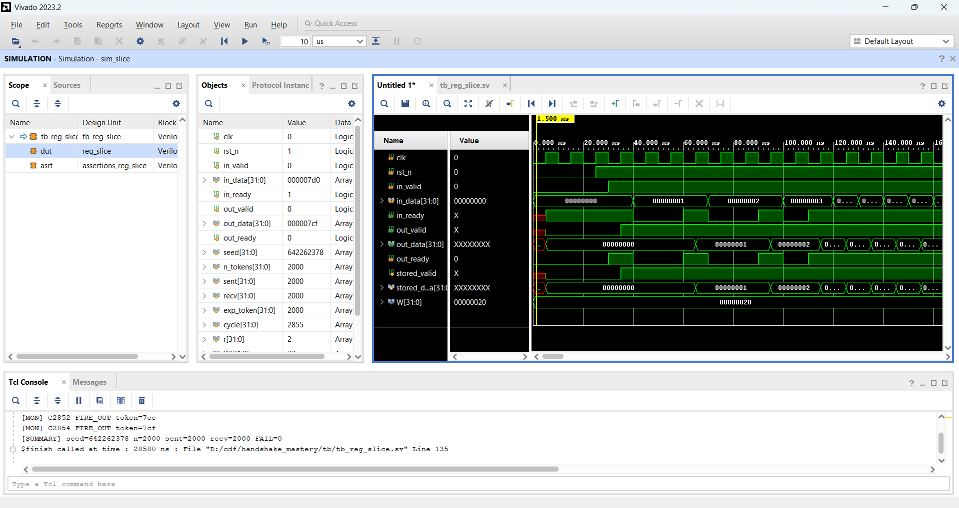
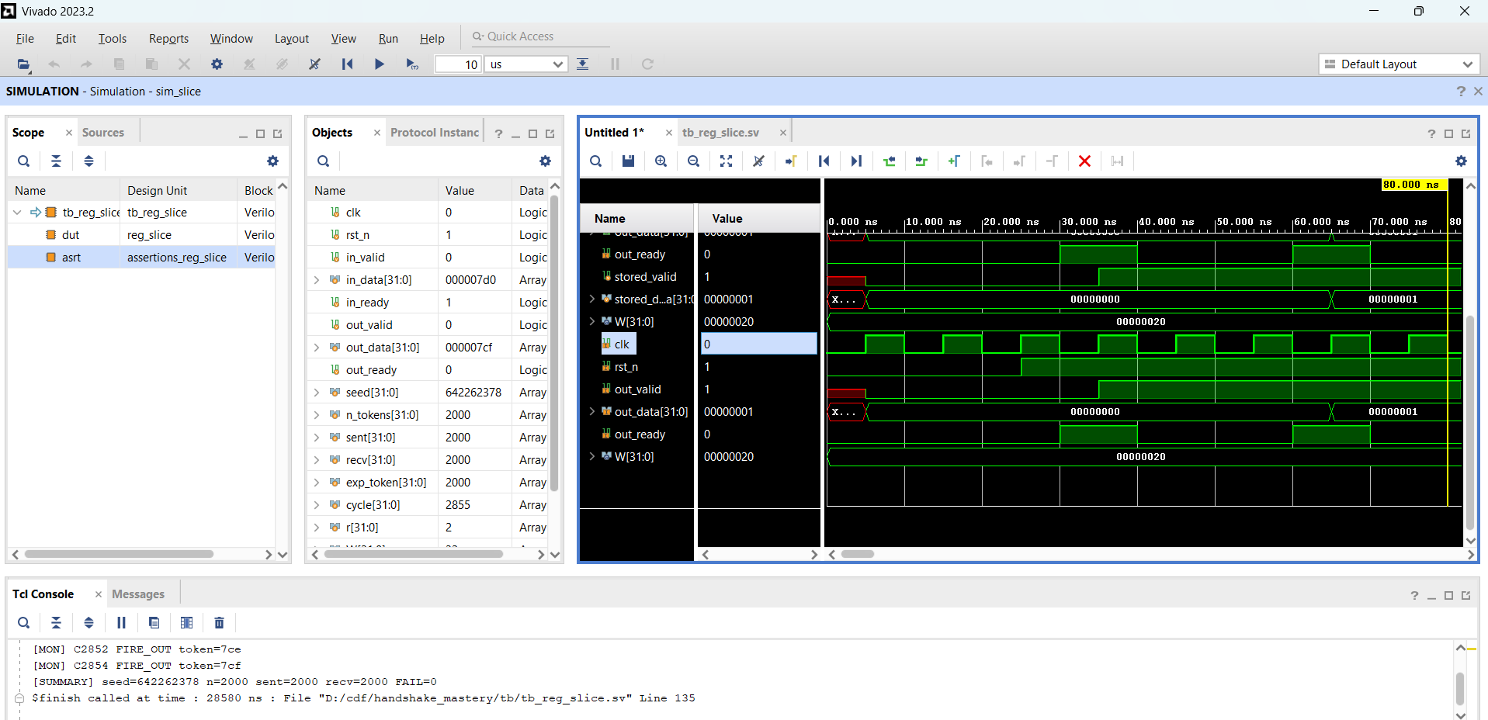

Take a screenshot of: Passing rerun summary with the same seed (file: screenshots/S22_bug_fixed_pass.png).

9. Packaging + Reproducibility + Evidence Checklist
Outcome: one command produces a clean run folder with reproducible settings, transcript log, and waveform database.
9.1 Required run folder contents
- command.txt (exact build/run commands used)
- transcript.log (PASS/FAIL summary + monitor lines)
- waves.wdb (XSIM waveform database)
- run_info.txt (seed, n, tag, date)
- optional: a short README in the run folder describing what this run demonstrates
Why is command.txt essential for reproducibility when you are not using Git?
The command.txt file records the exact commands used to build and run a simulation. This includes the compilation flags, source files, seed values, and run configuration.
Without Git version control, the command file ensures that anyone can reproduce the simulation environment and rerun the exact same experiment. If a failure occurs, the recorded commands allow the same configuration to be executed again to investigate the issue.
This makes the verification process transparent, reproducible, and easier to debug.
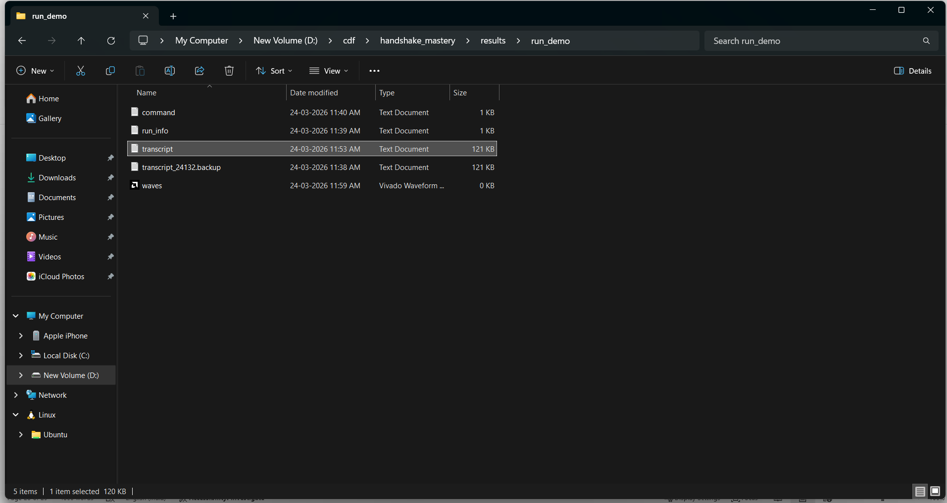
A passing run folder showing all required files (file: screenshots/S26_passing_run_folder.png).
9.2 Pass criteria (must be visible in transcript)
- All tokens delivered: recv == N
- No mismatches
- No assertion failures
- Transcript ends with a concise summary line including seed and N
[SUMMARY] seed=<N> n=<N>
[SUMMARY] sent=<N> recv=<N> FAIL=0

Transcript end showing summary line with FAIL=0 (file: screenshots/S27_final_summary.png).

Appendix A - Reference Commands (starter skeleton)
# Compile
xvlog -sv rtl/reg_slice.sv tb/tb_reg_slice.sv tb/assertions_reg_slice.sv
# Elaborate
xelab tb_reg_slice -debug typical -s sim_slice
# Run (log + wdb captured)
xsim sim_slice -R +seed=7 +n=2000 -log results/run_demo/transcript.log -wdb results/run_demo/waves.wdb
# Open waves (GUI)
xsim sim_slice -gui -wdb results/run_demo/waves.wdb

